EXHIBIT 7c1: IFCB Location Maps, Photos and C-HARM product screenshot

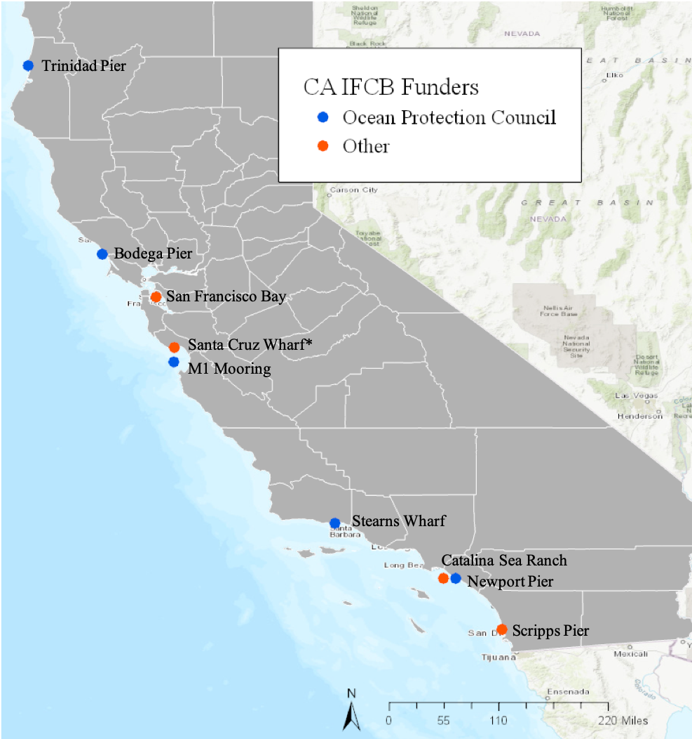
Figure 1 Map of nearshore (pier based) and offshore mooring IFCB locations

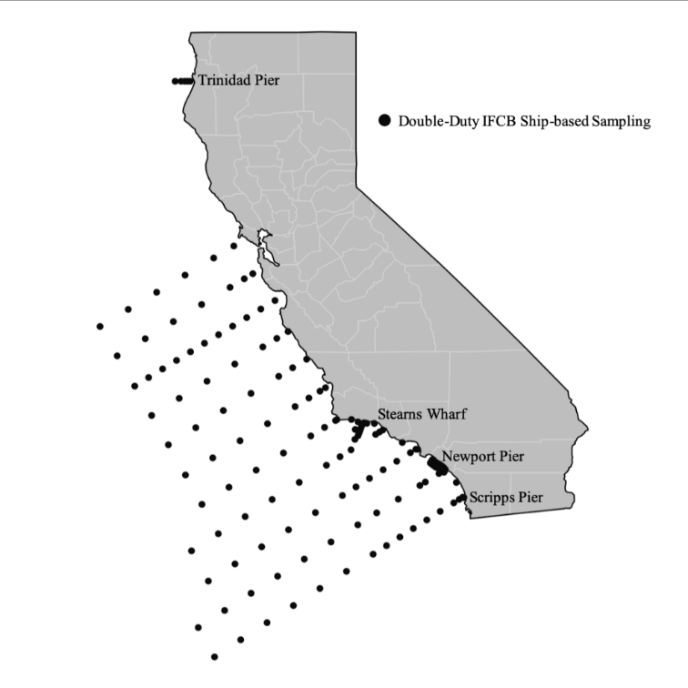
Figure 2 Scientific cruise transects where IFCBs will be used opportunistically doing “double duty”

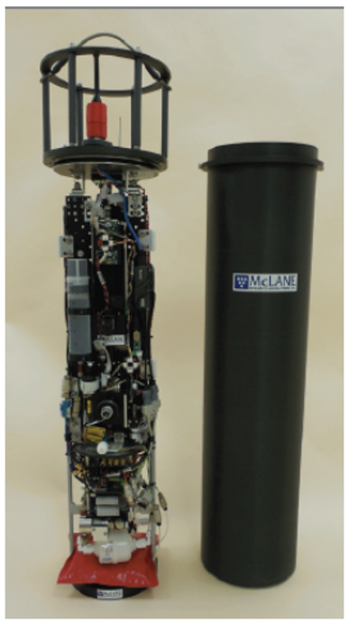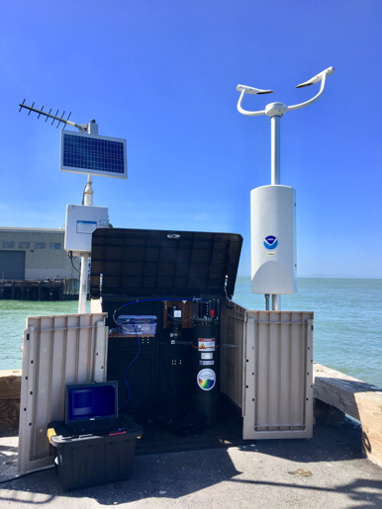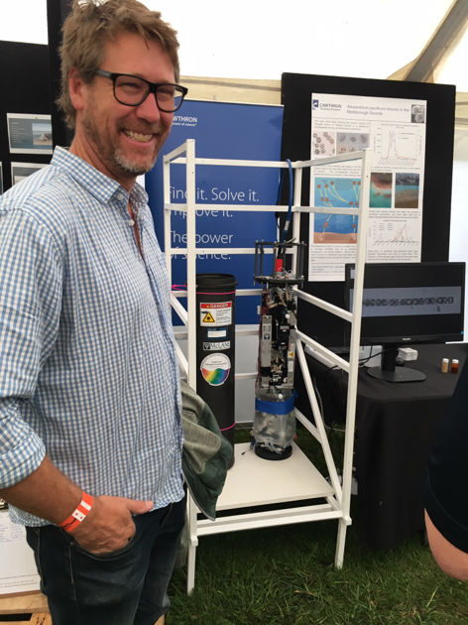
Photos of an Imaging Flow Cytobot alone, at the Exploratorium and next to a person for scale

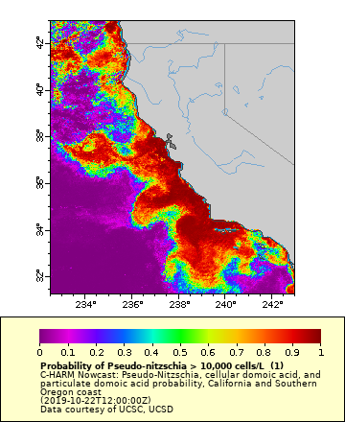
Figure 3: C-HARM model Nowcast probability of Pseudo-nitzschia on October 24, 2019

